Documentation &

Project Diary

Innovation Lab 1

Year 2024

Project: DIGITAL COPY

Team: 30

1. General Information

**Project name:** DIGITAL COPY

**Supervisor:** WAGNER FABIAN

Innovation Lab 1, winter term 2024

**Project team:**

project manager: Kment Nicolas, if23b306

Plachetzky Nicolai, if23b127

Licina Edin, if23b043

Kiri Nertil, if23b229

**Management Summary of the Project**

Our project is about an intensive care unit, where each of our team members will work on designing a 3D model of a defibrillator and a medical ventilator. In further semesters we would like to start implementing the function of the devices.

Priorities:

1. Learning how to use the software
2. Design the objects, without implementing functions
3. Start implementing functions

**Framework Conditions and Project Environment**

We will be using “Blender”, “VR”, “Unity”, “Oculus Quest 2”, and we tend to use C# as our programming language. Since we first must discover the methods of designing 3D objects in VR, our programming language might change, when we gain experience throughout the way.

There are no security standards to comply with.

**Semester-Roadmap**

3rd semester: Each member works on designing the two objects.

Divided by Sprints…

Since we have no experience with any of the used Software and C#, we will have to learn how to use Blender, Unity, the Oculus Quest 2, coding in C# and in Vr.

For this, we will need sprint 1 and 2 and in sprint 3 we will already try to implement some of the tasks (learning by doing).

In sprint 4 and 5 we hope to have gained enough experience and will be consistently modelling the objects.

4th semester: implementation of functions to objects

5th semester: combine all objects into one ICU

**Collaboration & Tooling**

Azure for project planning: <https://dev.azure.com/InnoDigitalCopy/Digital%20Copy>

Git: https://git.technikum-wien.at/innolab/digitalicu

1. **Brief Description of the Project**

Our aim for INNO1 is to design 3D models of a defibrillator and a medical ventilator. For now, they don’t need any functionality, since we want to focus solely on learning how to use the software and designing a plane 3D object, which can be viewed in VR. The goal for the first semester is to be done with modelling the defibrillator and the medical ventilator.

For INNO2, our aim is to start implementing the functionality of the objects. To achieve this, we need to be in constant collaboration with the experts of the ICU, to implement the correct functions. At the end of INNO2 we will have all the objects modelled in 3D and with implemented functionality.

Lastly, for INNO3, the goal is to combine all machines and projects into one room, which will then represent the ICU itself. If we fail to comply with all requirements of INNO2, we will continue implementing the functionality to certain objects after we have created the ICU room with all machines itself. At the end of INNO3 a working and interactive VR model of the ICU will be developed.

* In summary, this project is about creating an interactive VR model of a defibrillator and a medical ventilator step by step
* The greatest challenge will be learning how to create interactive VR objects with functionality. After that, probably comes understanding how each object should work, and implement the functionality
* To add value to the project, the VR model of the ICU needs to be interactive, and the machines need to work

In order to implement our solution, we will achieve our sprint tasks and work towards our goals step by step. We will help each other, watch tutorials and ask experts for help if needed.

Procedure:

INNO1: Design a defibrillator and a medical ventilator.

INNO2: Implement functionality for these objects.

INNO3: Combine all objects into a fully interactive VR room.

ORDER Model Clarification:

1. O - Opportunity:  
   Our key goals for each INNO phase are as described in “Procedure”.
2. R - Resources:  
   all resources and tools for our project are open source and work on all our personal computers.
3. D - Decision:  
   Our project leader will approve of milestones together with our supervisor. When a change must be made, we will all together do a replanning of a given sprint.
4. **Specification of the Solution**

We decided as a team to create a table that shows our epics and user Story’s. This is an overview of how everything should work out.

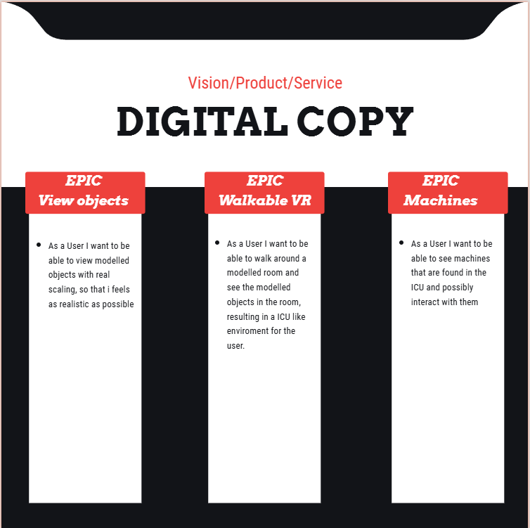

1. **Effort Estimation**

**INNO1:**

We estimate that each person will invest about 14 hours of their time in each sprint. There are 5 sprints in total, and at the end (Project completion) we estimate each one of us to invest 2 hours in the final presentation. This is a total of 72 hours, starting with the first sprint. If the Product backlog and system specifications phase is calculated, it’s 3 more hours, each of us put into this project. This is a total of about 75 hours per student.

We estimate that more than half of the time will be spent on learning how to use Unity, Blender, the oculus quest 2, C# and how all of it works together with VR. 70 hours per student is the total time we estimate to spend on sprints and 50 hours will be learning and gaining experience. The remaining 20 hours we expect to invest in just continuing our work and repeating patterns and methods of modelling as we have already learned at this point.

**INNO 2:**

Using the Delphi method, we came to a total of 71hours just for development. At first this seems only a little but since we have only a little experience, we might need longer for pure development, and even longer for debugging and especially error finding. Besides that, there is a lot of documentation to be made each sprint, that being the sprint review protocols, project diary and specification of the solution. At the end we also have to fill the “Delivery” section of the protocol.

Ein Bild, das Text, Screenshot, Zahl, parallel enthält.
Delphi Method

These User stories will be included in the next topic **“Semester Roadmap”** under separate sprints of **INNO2**.

**INNO 3:**

Using the Delphi method, we came to a total of 46hours just for development. This is even less than last semester, but the circumstances have also changed…

* This semester we are less students in the group
* We had prior problems setting up Unity version control but this time we dedicated the first sprint for setting up unity version control, so everybody can work from home on the project.
* We have also had problems pushing the project’s source code to GitHub for a whole year now. We will be trying to fix that in the first sprint as well.

Both the unity version control and the GitHub problem were not included in the Delphi estimation since they are not predictable.

Other than that, like last semester, there is a lot of documentation to be done along the way.

**Ein Bild, das Text, Reihe, Zahl, Schrift enthält.
**Delphi Method

These User stories will be included in the next topic **“Semester Roadmap”** under separate sprints of **INNO3**.

1. **Semester Roadmap**

**INNO2:**

Sprint 1 – delphi estimate 16h

* [Issue 38](https://dev.azure.com/InnoDigitalCopy/Digital%20Copy/_workitems/edit/38): als User möchte ich das Beatmungsgerät aus der ICU in VR verwenden, um Simulationen durchzuführen
* [Issue 46](https://dev.azure.com/InnoDigitalCopy/Digital%20Copy/_workitems/edit/46): Als 3D-Artist möchte ich einen realistischen Defibrillator modellieren, damit er in der ICU-VR-Umgebung authentisch wirkt.
* [Issue 52](https://dev.azure.com/InnoDigitalCopy/Digital%20Copy/_workitems/edit/52): Als Nutzer möchte ich einen realistischen und maßstabsgetreuen ICU-Raum in VR betreten, um eine immersive Trainingsumgebung zu haben.

Sprint 2 – delphi estimate 33h

* [Issue 41](https://dev.azure.com/InnoDigitalCopy/Digital%20Copy/_workitems/edit/41): als User möchte ich, dass das Beatmungsgerät so angenähert, wie das aus der ICU in der FHTW aussieht, damit ich Simulationen und Lernvideos speziell für die FH erstellen kann
* [Issue 47](https://dev.azure.com/InnoDigitalCopy/Digital%20Copy/_workitems/edit/47): Als 3D-Artist möchte ich einen detaillierten Defibrillator mit realistischen Materialien modellieren, damit er in der ICU-VR-Umgebung immersiv wirkt.
* [Issue 53](https://dev.azure.com/InnoDigitalCopy/Digital%20Copy/_workitems/edit/53): Als Nutzer möchte ich im virtuellen ICU-Raum einige Grund Geräte sehen können, um mich möglichst realitätsnah orientieren zu können.

Sprint 3 – delphi estimate 8h

* [Issue 34](https://dev.azure.com/InnoDigitalCopy/Digital%20Copy/_workitems/edit/34): als User möchte ich mich im raum frei bewegen können, um meine Arbeit in der ICU simulieren zu können
* [Issue 25](https://dev.azure.com/InnoDigitalCopy/Digital%20Copy/_workitems/edit/25): Ich als User möchte die ICU Objekte bewegen können damit ich mir ein gemütliches Setup einrichten kann

Sprint 4 – delphi estimate 9h

* [Issue 37](https://dev.azure.com/InnoDigitalCopy/Digital%20Copy/_workitems/edit/37): als User möchte ich das Beatmungsgerät ein/ausschalten können, damit ich meine Simulation damit starten kann
* [Issue 28](https://dev.azure.com/InnoDigitalCopy/Digital%20Copy/_workitems/edit/28): Als User möchte ich den Defibrillator einschalten/ausschalten können, damit ich in der VR-Intensivstation realistisch Notfälle simulieren kann

Sprint 5 – delphi estimate 5h

* [Issue 31](https://dev.azure.com/InnoDigitalCopy/Digital%20Copy/_workitems/edit/31): Als User möchte ich Vitalparameter auf dem Monitor sehen, damit ich den Zustand des Patienten beurteilen und angemessen reagieren kann

Sprint 6 – no delphi estimate / depends on the circumstances

* Time for Debugging & error finding or executing undone tasks / implementing additional tasks

Sprint 7 – no delphi estimate / depends on the circumstances

* Preparing presentation, creating document collection, upload source code and other essentials

**INNO3:**

Sprint 1 – no delphi estimate / depends on the circumstances

* Set up Unity Version control and find a way to upload the project to a repository / also communicate with Lecturer on what exactly all devices must do.

Sprint 2 – delphi estimate -

* [Issue 65](https://dev.azure.com/InnoDigitalCopy/Digital%20Copy/_workitems/edit/65): Ich als User möchte ein realitätsgetreues **Beatmungsgerät** in der ICU stehen haben, damit sich die Umgebung immersiv anfühlt
* [Issue 61](https://dev.azure.com/InnoDigitalCopy/Digital%20Copy/_workitems/edit/61): Ich als User möchte einen Realitätsgetreuen **Defibrillator** in der ICU stehen haben, damit sich die Umgebung immersiv anfühlt

Sprint 3 – delphi estimate -

* [Issue 69](https://dev.azure.com/InnoDigitalCopy/Digital%20Copy/_workitems/edit/69): Ich als User möchte realitätsgetreu den **Defibrillator** greifen können, damit ich für einen Gebrauch eines Defis in der reellen Welt trainieren kann

Sprint 4 – delphi estimate –

* [Issue 73](https://dev.azure.com/InnoDigitalCopy/Digital%20Copy/_workitems/edit/73): Ich als User möchte realitätsgetreu die Funktionen des **Beatmungsgerätes** starten können, damit ich für eine Anwendung im reellen Leben vorbereitet bin

Sprint 5 – delphi estimate -

* [Issue 78](https://dev.azure.com/InnoDigitalCopy/Digital%20Copy/_workitems/edit/78): Als User möchte ich eine Realitätsgetreue Reaktion des **Defibrillators** erleben, wenn das Gerät bedient wird, um mich auf die Bedienung im reellen Leben vorzubereiten
* [Issue 81](https://dev.azure.com/InnoDigitalCopy/Digital%20Copy/_workitems/edit/81): Als User möchte ich eine Realitätsgetreue Reaktion des **Beatmungsgeräts** erleben, wenn das Gerät bedient wird, um mich auf die Bedienung im reellen Leben vorzubereiten

Sprint 6 – no delphi estimate / depends on the circumstances

* [Issue 84](https://dev.azure.com/InnoDigitalCopy/Digital%20Copy/_workitems/edit/84): Als User möchte ich in der Lage sein den Defi an einer Person zu testen damit ich für das echte Leben vorbereitet bin
* Time for Debugging & error finding or executing undone tasks / implementing additional tasks

Sprint 7 – no delphi estimate / depends on the circumstances

* Preparing presentation, creating document collection, upload source code and other essentials

1. **Delivery**

For the Developer

* To be safe, anticipate the Project Folder to have a size of 8gb
* No licenses required
* No specifically strong hardware is needed. For best compatibility the Developer should use a Meta Quest 2 VR-Headset.
* The Project can be downloaded from Unity Version Control

For the User

* The ICU.apk has a total size of 50mb
* No licenses required
* For best compatibility the User should use a Meta Quest 2 VR-Headset, since we did not have the possibility to test on other Headsets.
* The Project can be downloaded as an APK from our Git.

1. **Our Project Diary**

**INNO1:**

The first phase of the ICU VR project focused on creating a walkable VR environment that included a room with essential objects such as a bed and a table. This milestone marked the completion of the foundational aspects of the project.

Team Reflection

To review our progress, the team convened for a meeting over a meal. During this session, we reflected on our experiences, challenges, and accomplishments throughout phase one.

Key Points Discussed

Learning Blender for 3D Modeling:

None of the team members had prior experience with Blender, making it a completely new venture. Despite this, we successfully created the necessary 3D models for the project.

Importing Blender Objects into Unity:

Correctly importing Blender objects into Unity was initially challenging, particularly in handling materials. Over time, we identified solutions and improved our workflow.

Scaling and Sizing:

Ensuring the correct scaling of objects in the VR environment proved difficult. Adjustments were made to align the objects to realistic proportions.

Time Management:

We acknowledge that our time management could have been better. While we achieved significant progress, a more structured approach could have allowed us to accomplish even more.

Conclusion

Despite the challenges, the team was content with our progress. Considering the need to learn new technologies from scratch, such as Blender and Unity, we feel confident moving forward. This phase has provided us with valuable experience and insights to improve in the next stages of the project.

Further down there are Screenshots of the process of modelling and how the room looks in VR for now. The video is going to be more detailed on that.

First steps in modelling in Blender.

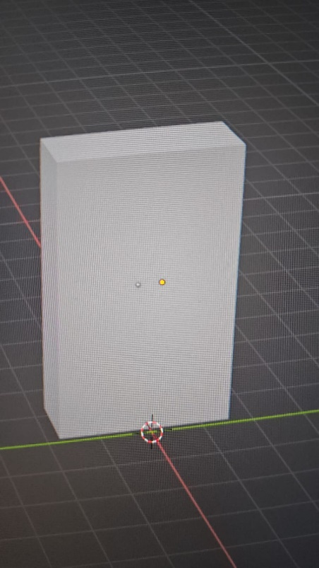 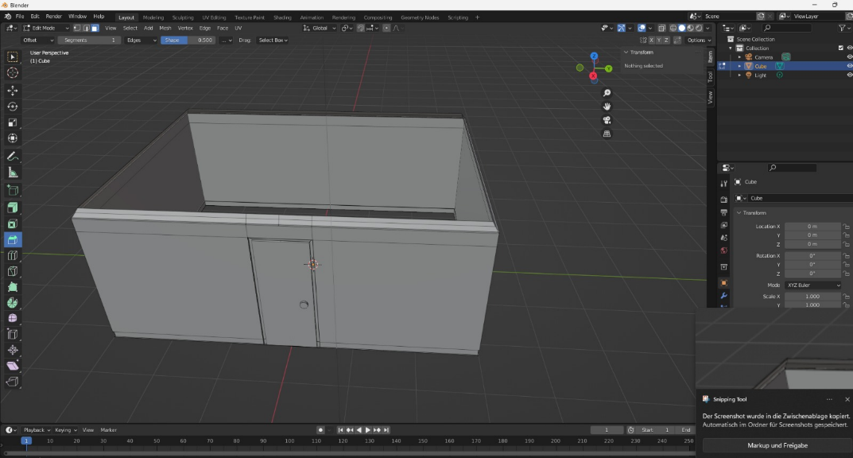

Ein Bild, das Computer, Text, Screenshot, Multimedia enthält.

Object scaling issues

The “finished” Room and how it looks in VR

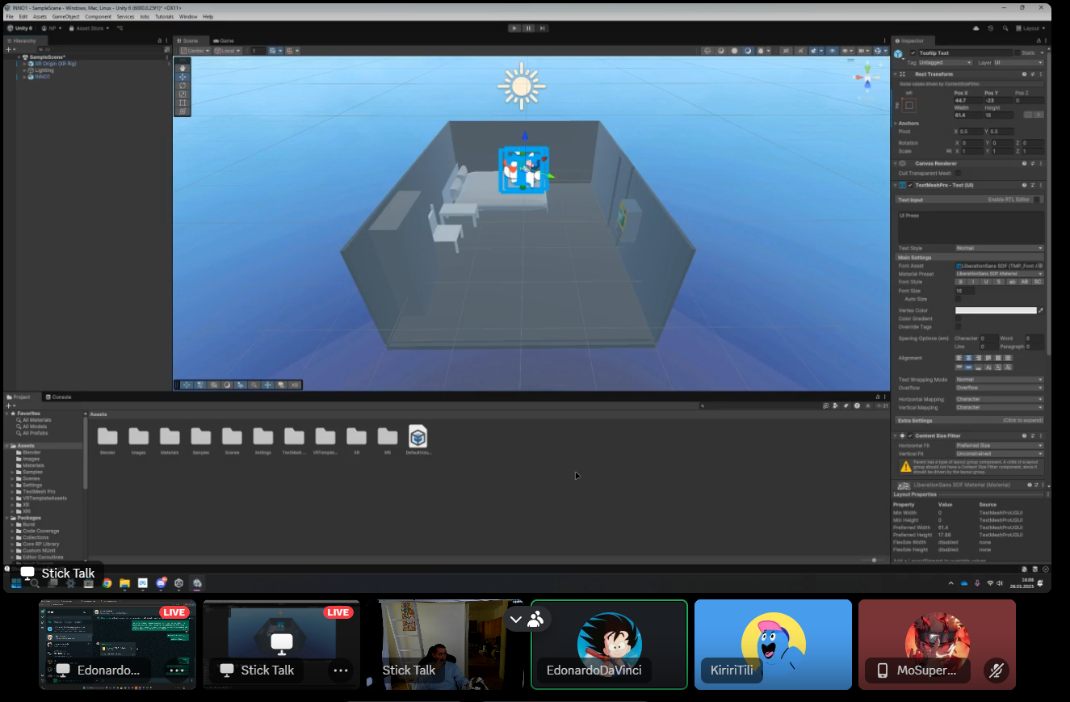

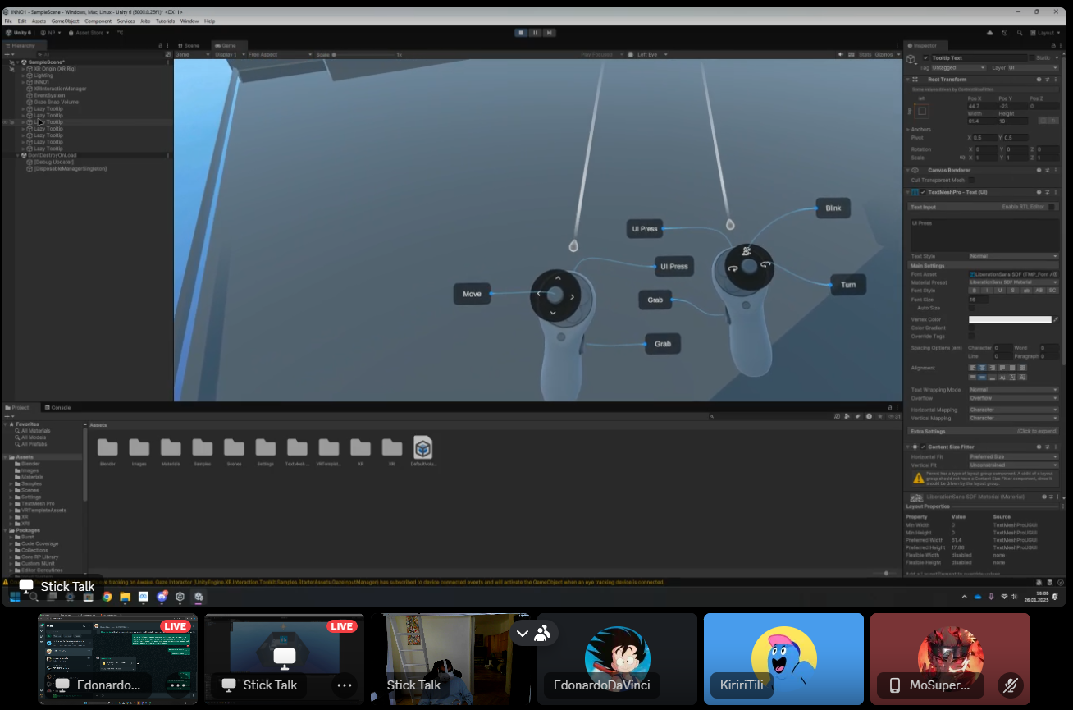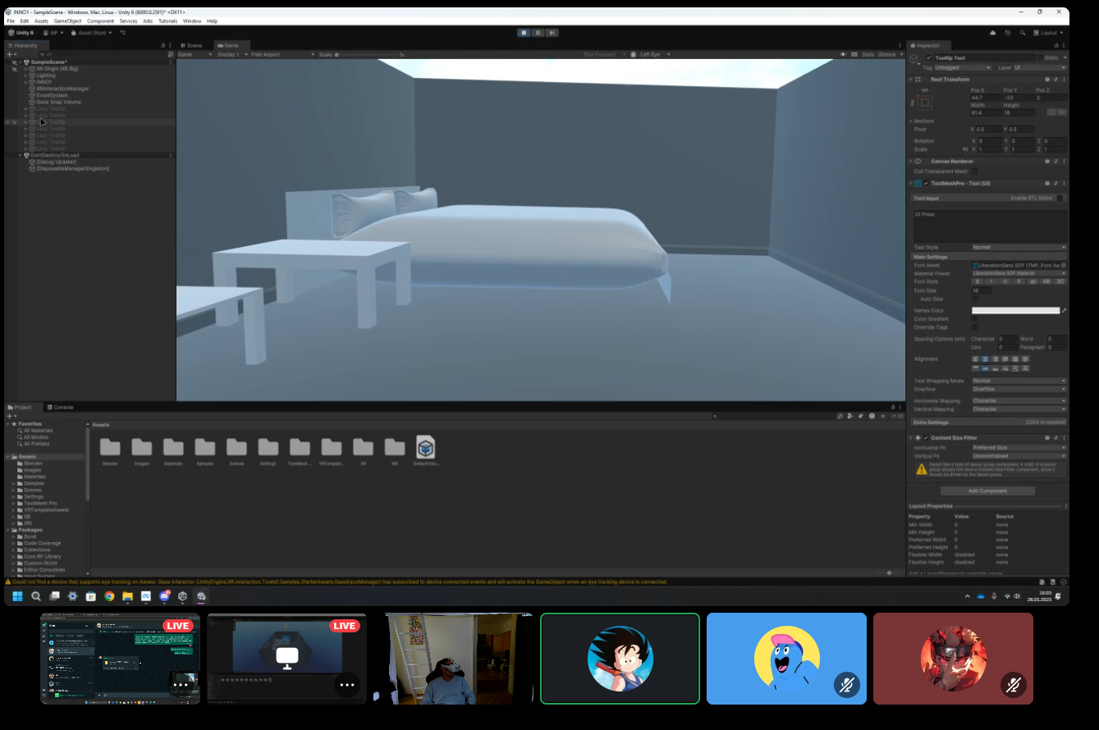

**INNO2:**

The first phase of this Semester focused on creating the real ICU room as a walkable VR environment that includes some random objects such as the table, the board, etc.

Team Reflection

To review our progress, we often organized meetings in the university. During these sessions, we spoke about the challenges, what worked and how to help each other.

Key Points Discussed

Using Blender for 3D Modeling:

We had experience in Blender from the First INNO LAB, now we managed to mostly complete the Blender side of the Project. What is missing is some tweaks and bits to the Defibrillator.

Importing Blender Objects into Unity:

Correctly importing Blender objects into Unity even including their animations was no problem. Making the animation run correctly later was more of a hustle.

Scaling and Sizing:

To avoid problems with unity and compatibility of all objects, we ensured to apply perfect scaling and sizing to out Blender Objects. First, we had to take all measurements of the real-world Objects in the ICU and then we were ready to go.

Time Management:

We noticed a remarkable improvement in time management since INNO1. We achieved much more than INNO1, but then again, we already were a bit familiar with Blender and Unity this semester.

Conclusion

We faced great challenges this semester since we strived for perfection in some aspects (precision for our Blender objects). Compared to learning Blender and Unity from scratch, it was not such a big deal but still very time-consuming. We even managed to bring a lot of functionality to Unity and still only mostly finished all Blender Objects. Other than that we have improved a lot since INNO1 and strive for even better teamwork.

Further down there are Screenshots of the process of modelling and how the room looks in VR for now. The video will have more detail on that.

**Defibrillator**

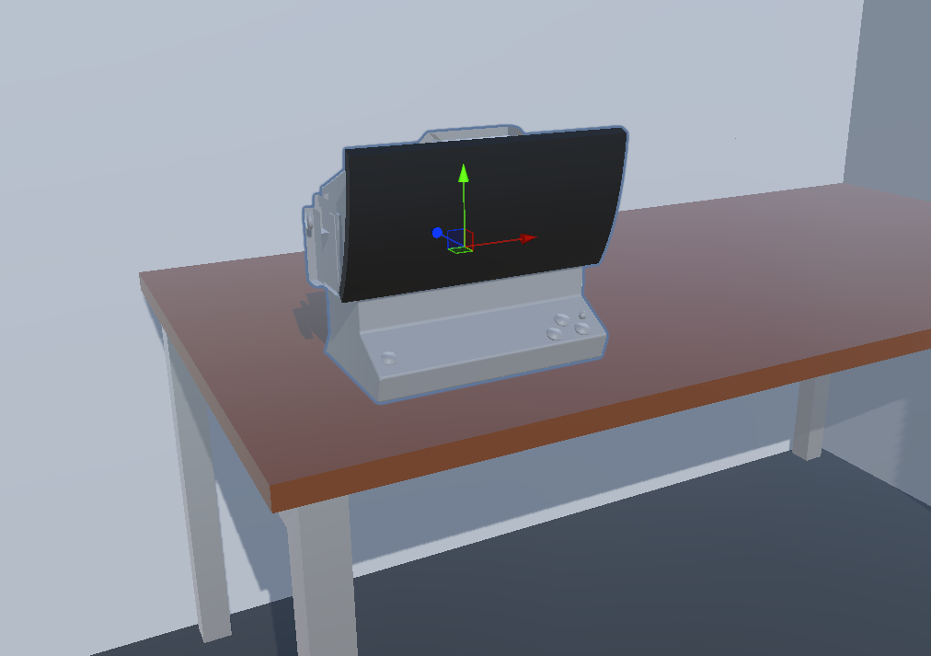Ein Bild, das Screenshot, Design enthält.

**Ventilator**

Ein Bild, das Text, Screenshot, Gas, Design enthält.
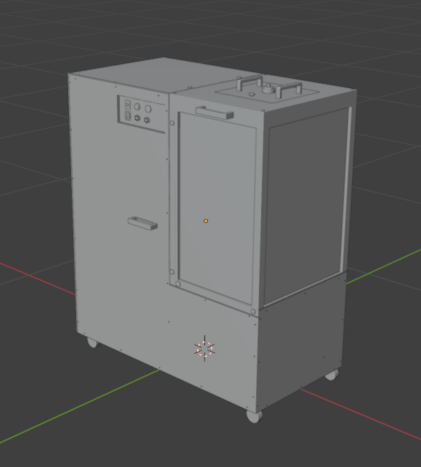

**Room**

Ein Bild, das Screenshot, Haus, Fenster enthält.

Ein Bild, das Rechteck, Screenshot, Design, Mobiliar enthält.

**Board**

Ein Bild, das Screenshot, Design enthält.
Ein Bild, das Tripod, Leiter, Staffelei, Kunst enthält.

**Some Detail**

Many Objects

Ein Bild, das Wand, Mobiliar, Inneneinrichtung, Im Haus enthält.

Sink

Ein Bild, das Waschbecken, Design, Tisch enthält.

Television

Ein Bild, das Screenshot, Design enthält.

Roof

Ein Bild, das Screenshot, Reihe enthält.

closet

Ein Bild, das Behälter, Design, Box enthält.

Start/Stop for Ventilator

Ein Bild, das Text, Handschrift, Schrift, Design enthält.

TableEin Bild, das Mobiliar, Tisch, Design enthält.

**INNO3:**